**1.TRELLO BOARD CREATED – STUDENT TASK MANAGEMENT-AGILE BOARD**

**2.LISTS ARE CREATED**

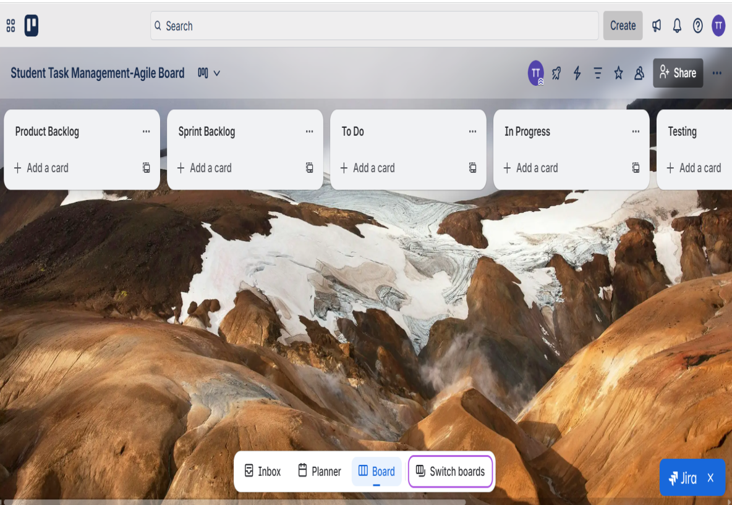

**3. ADDED STORIES**

**4.SPRINT IS PLANNED AND STARTED WORKS**

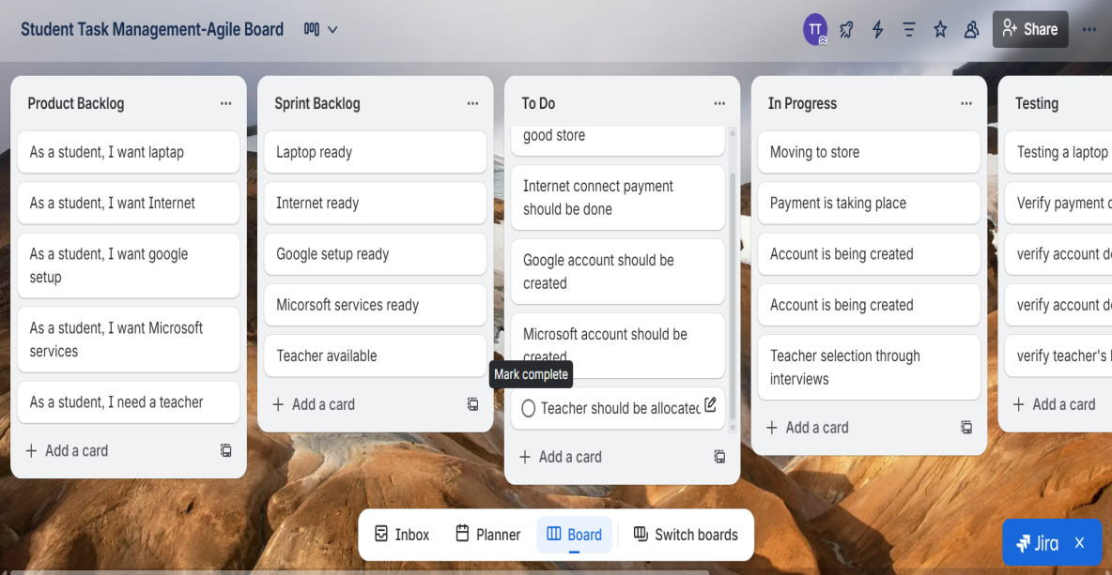

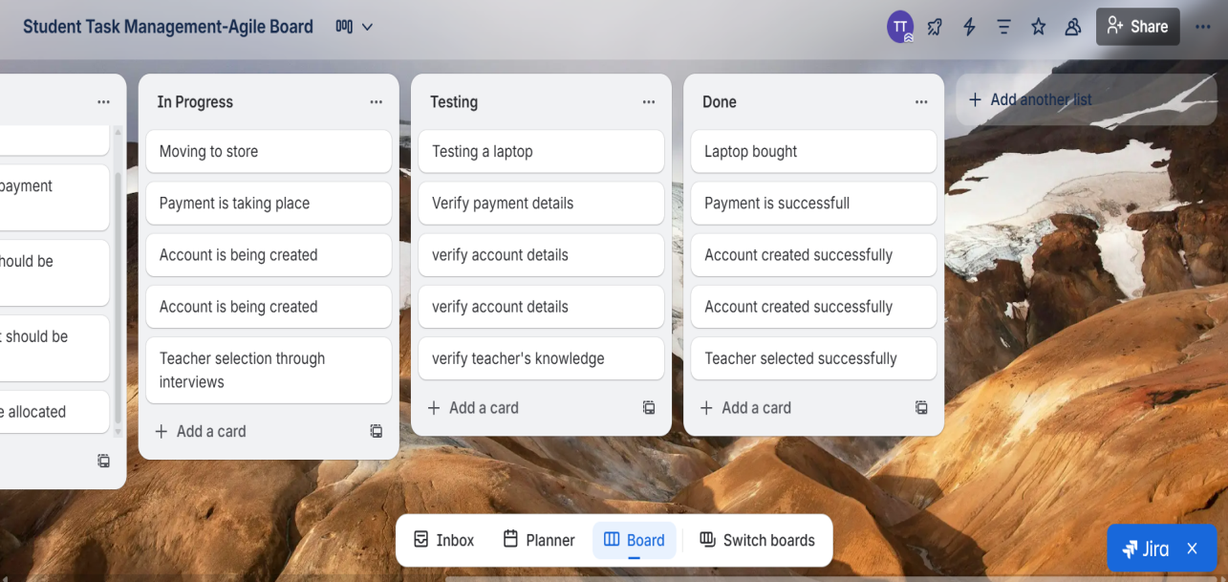

**5.PRIORITY LABLES CREATED**

**6.DEADLINES ARE ASSIGNED**

